GENI Lab 1 (15 points), **3:30pm, 09/04/2019**

Name: Johnnie Oldfield

Student #: 870578517

Login to nodes:

Client login: ssh: jboldfie@pc1.genirack.nyu -p 26810

Server login: ssh; jboldfie@pc1.genirack.nyu.edu -p 26811

Internet

Control Plane Switch

Client

Data i/f: eth1

ip: 10.10.1.1

Data i/f: eth1

ip: 10.10.1.2

Server

Data Plane Switch

Control i/f: eth0

ip: 172.17.1.32

Control i/f: eth0

ip: 172.17.1.31

Answer the following questions

1.2.d.

What is the bandwidth of this link? 97.0 Mbits/sec

Why -- Attach screenshot of the client ssh terminal:

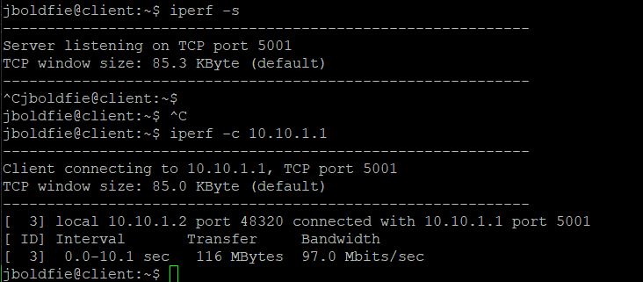

Attach screenshot of the server ssh terminal:

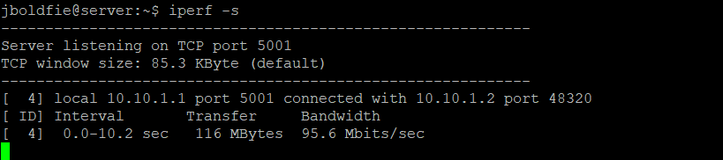

1.2.e.

What is the bandwidth of this link? 5.04 Gbits/sec

Why -- Attach screenshot of the client ssh terminal:

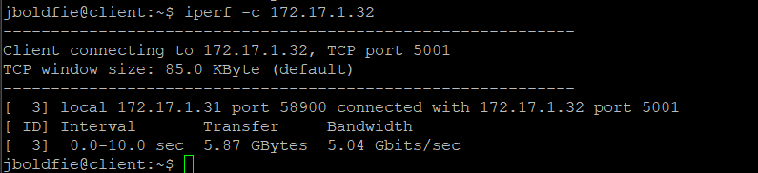

Attach screenshot of the server ssh terminal:

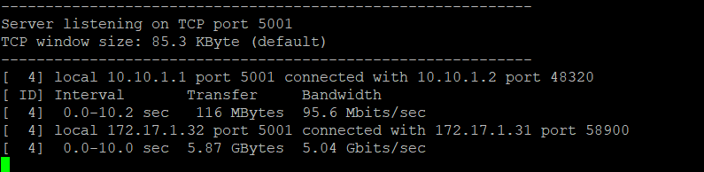

1.3

Attach screenshot of the client ssh terminal. Make sure the screenshot includes the successful pings, “…Destination Host Unreachable” messages, and successful pings again:

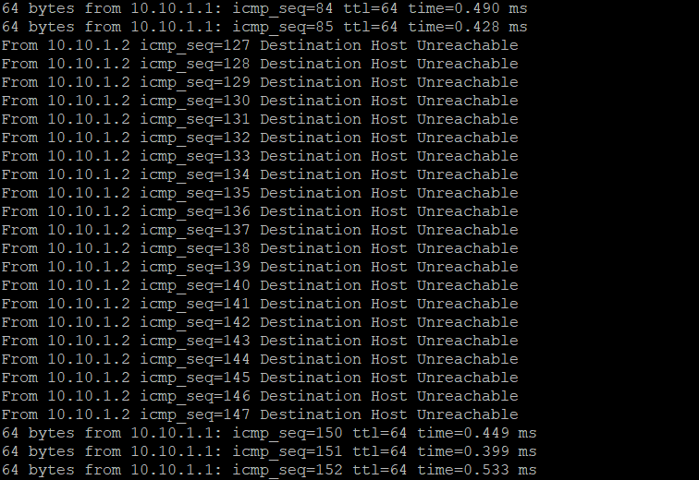

Attach screenshot of the server ssh terminal. Make sure the screenshot includes both the “sudo ifconfig <server data i/f name> down” and “sudo ifconfig <server data i/f name> up” commands.

